* **[How to edit a Wiki page](https://sharepoint.rackspace.com/Learning/Articles/Pages/SharePoint-2013--how-to-edit-a-wiki-page.aspx)**

In the tutorial, [**How to create a Wiki Page**](https://sharepoint.rackspace.com/Learning/Articles/Pages/SharePoint-2013--how-to-create-a-wiki-page.aspx) I create a page called “Site Upgrade”.  In this tutorial, I will demonstrate how to edit the “Site Upgrade” page.  Some things in SharePoint aren’t always straightforward and if you’re new to SharePoint 2013 or SharePoint in general, this can be more difficult than you would think.    
  
1. From your SharePoint site, on the quick launch, click **Site Contents**.

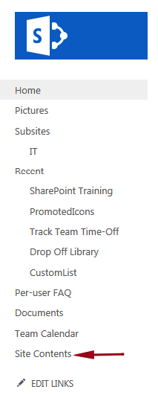

2. Under Lists, Libraries and other Apps click **Site Pages**.  
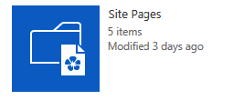  
   
3. From the list of pages, click **Site Upgrade**.  
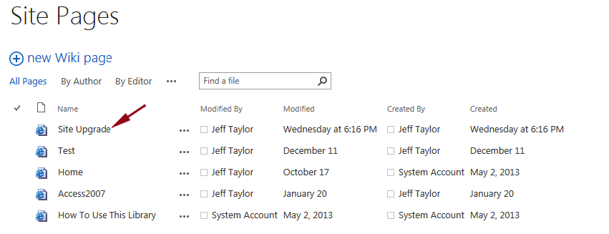   
4. To start editing the page, in the upper-left click **Page**.

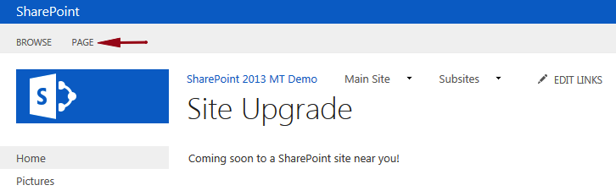

5. In the edit section of the ribbon click Edit.  
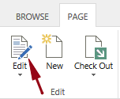  
   
6. Highlight “Coming soon to a SharePoint site near you!”

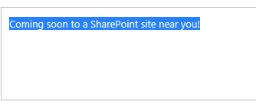

7. In the Styles section of the ribbon click **Heading 1**.

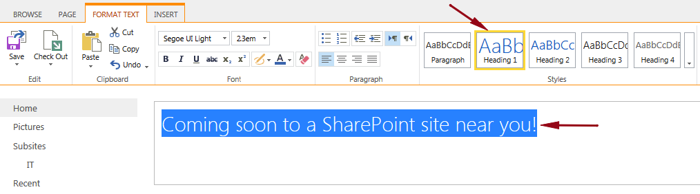

8. Click below “Coming soon to a SharePoint site near you!”

9. Type the following “**The SharePoint upgrade is scheduled for January 2nd, 2015**”.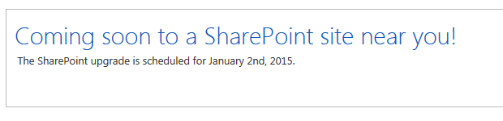  
  
10. In the upper-left click Save.

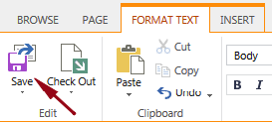

11. Check out the updated page!

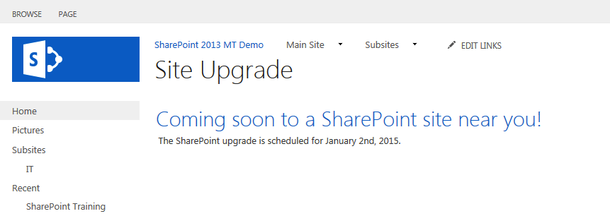

You have successfully edited a SharePoint Wiki page!  Now you can go back in and make additional changes to best fit your needs.